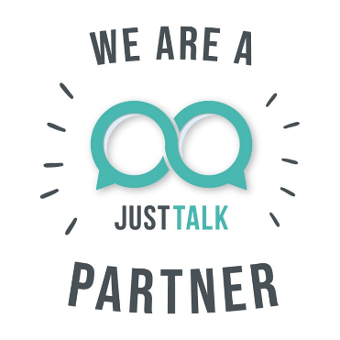

Join Us to Celebrate Just Talk Week 2023!
HWEICB Healthier Together is a proud Just Talk Partner and we are excited to join together to celebrate Just Talk Week 2023.
Just Talk is an initiative that encourages open conversations about mental health among children and young people, collaborating with over 40 health, social care, education, and voluntary organisations across Hertfordshire. The programme is steered by young people themselves, creating resources, guidance and support to help navigate the ups and downs of life.
[Organisation name] is dedicated to the emotional wellbeing of Hertfordshire’s youth and is actively involved in the Just Talk programme, championing positive mental health messages and support for young people.
This year Just Talk is kicking off its seventh annual Just Talk Week on Monday, 20th November and it’s all about going ‘Back to Basics’, with a focus on ensuring that children and young people, parents, carers, schools and professionals across Hertfordshire have awareness of campaign as well as the resources available. It’s a week full of valuable insights and activities, all aimed at strengthening emotional wellbeing.
We encourage young people, parents, carers, and professionals working with young people to get involved. For more information about Just Talk Week, visit Just Talk Week 2023 and follow @JustTalkHerts on Facebook, Instagram, and Twitter.

