HOW TO RECOGNISE AN ASTHMA ATTACK

It is important that you recognise the signs and symptoms of an asthma attack in your pupil. Be aware that the onset of an asthma attack can gradually appear over days. Early recognition will help prevent your pupil from getting worse and needing to go in to hospital.

Your pupil may have one or more of these symptoms during an asthma attack:

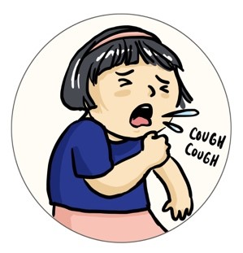
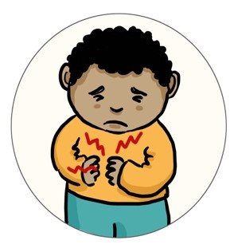
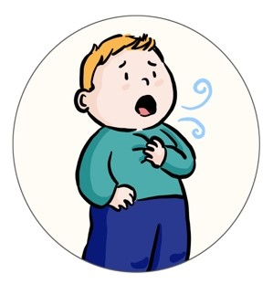
BREATHING HARD AND FAST
You may notice your pupil breathes faster or is having chest ‘recessions’ which is the pulling in of muscles in between the ribs or underneath the ribs.

WHEEZING
This is typically a high-pitched whistling noise heard on breathing in and out, a sound produced by inflamed and narrowed airways that occur in asthma.

COUGHING
Your pupil may have a worsening cough, particularly at night preventing your child from having restful sleep and making them seem more tired in class.

BREATHLESSNESS
Your pupil may appear to be less active, with refusal to eat, or they may seem restless. This may be a sign that they are too breathless to run around and do PE or even eat

TUMMY OR CHEST ACHE
Be aware that younger children often complain of tummy ache when it is actually their chest that is causing them discomfort.
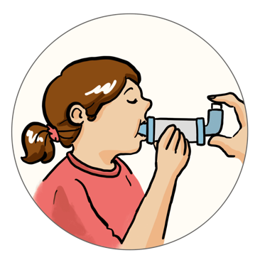

INCREASED USE OF THE RELIEVER INHALER
If your pupil is old enough, he/she may ask for the reliever inhaler more frequently during an attack. It is important that you follow your pupil’s asthma action plan and know when to seek help when the reliever inhaler fails to improve their symptoms.

