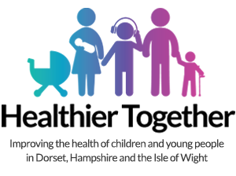
Emergency Department interactive workshops – facilitator guide

Thank you for taking the time to run the workshop. Please find some tips below to help run it as smoothly as possible.

- These workshops have been designed by Paediatric Emergency Medicine consultants
- They are designed to be delivered as part of local teaching in the regional emergency departments.
- They cover the conditions most commonly seen and are suitable for medical trainees, clinical practitioners and nurses.
- Each workshop takes 30-45 minutes to deliver
- Please consider printing the slides as handouts
- Notes at the bottom of each slide provide additional information for the facilitator and links to additional resources
- Please run the workshop on an internet enabled computer as the slides use hyperlinks to Wessex Healthier Together resources
- Please include demonstrations of how to access Wessex Healthier Together resources ie pathways and safety netting sheets within the Professionals>Hospital Staff>Clinical Paediatric Pathways OR Safety netting documents for parents.
  - Explain that safety netting sheets can be easily texted to parents using the SMS share function (which will be sent from the Healthier Together website as opposed to your personal mobile phone number!)
  - Explain that Wessex Healthier Together has embedded google translate functionality to translate the page on screen into a wide range of languages. This can then be printed by right clicking on the web page and selecting print.
- If you have any questions or suggestions please email: David.james@uhs.nhs.uk or alan.charters@porthosp.nhs.uk

