Spring/Summer promotion of Herts and West Essex Healthier Together website
Tailored toolkit for HWE ICS
Background
The Healthier Together website was developed to provide parents with easily accessible information about common childhood illnesses including when and where to get help and to also offer support to healthcare professionals to make sure consistent messages are given to parents.
It includes close collaboration with professionals across health and social care (schools, local authorities, health visitors, school nurses, practice nurses, acute children’s community nurses, GPs, midwives, ambulance services and NHS 111).
With the warmer seasons ahead, the aim of this toolkit is to continue to remind parents about this valuable resource.
Key messages for parents
- It’s an online resource to help provide information to parents who have concerns about the health and wellbeing of their children
- Clear and trusted advice from local health care providers
- ‘One stop shop’ for information about common illnesses, ailments and injury
- Local and up to date information

Website

The following is shared on the HWE ICS website. You are welcome to replicate this text on your own site:

Template copy
Health advice all in one place for your family this summer

While the arrival of warm temperatures and sunny skies in the summer is usually welcome, it’s good to know what health challenges children and families may face this season to help them stay safe when out and about or at home enjoying the sunshine.

With the summer holidays fast approaching, many families may be traveling abroad. Therefore, it’s important families ensure everyone is vaccinated to protect from serious diseases found overseas.

For those families staying closer to home, holidaying in the UK or just heading to the beach or elsewhere for a day out, knowing how to stay safe in the sun and around water will help to reduce stress and worry so they can focus on having fun.

It can be a hugely worrying time to have poorly children and you will want to know what symptoms to look out for, get advice on what to do in the first instance and know when you need to call in professional help.

Clinical leaders of local health and care services have created a website you can go directly to which offers useful information and trusted advice direct from health professionals all in one place.

The Hertfordshire and west Essex Healthier Together website has up-to-date information, advice and guidance on a number of topics, including:

- Allergies
- Managing hay fever
- Community pharmacy
- Staying safe over the summer
- Sunscreen safety
- Keeping safe in the water
- Oral health
- Healthy weight

The site advises on the common symptoms of a number of conditions, what steps you should take to treat them at home and when to think about seeking further help.

Dr Rachel Joyce, Medical director for Herts and West Essex ICB, said: “It is sometimes hard to know what your next steps are when your children are unwell and what to look out for in those symptoms if they are normal or you should get extra medical help.

“This website gives parents that information about a range of childhood illnesses, all in one place and supplied by trusted health experts, to make that decision. It also has a range of information on important topics and places you can get extra support.”

Please share this website with your own friends and family and help them get much needed support and advice for their own loved ones when they need it.

Newsletter articles

The following articles will be used by HWE ICB for internal and external newsletters, and you are encouraged to share these within your own similar publications:

Target audience | Template copy
Public newsletter (long version) | Get expert advice this summer with the Healthier Together website  While the arrival of warm temperatures and sunny skies in the summer is usually welcome, it’s good to know what health challenges children and families may face this season to help them stay safe when out and about or at home enjoying the sunshine.  With the summer holidays fast approaching, many families may be traveling abroad. Therefore, it’s important families ensure everyone is vaccinated to protect from serious diseases found overseas.  It can be a hugely worrying time to have poorly children and you will want to know what symptoms to look out for, get advice on what to do in the first instance and know when you need to call in professional help.  There is a bespoke website, created by clinical leaders of local health and care services that can help with useful information and trusted advice, all in one place and directly from health professionals.  The Hertfordshire and west Essex Healthier Together website advises on the common symptoms of a number of childhood conditions, what steps you should take to treat them at home and when to think about getting further help.  This includes advice and guidance on:  - Allergies  - Managing hay fever  - Community pharmacy  - Staying safe over the summer  - Sun screen safety  - Keeping safe in the water  - Oral health  - Healthy weight  Dr Rachel Joyce, Medical director for Herts and West Essex ICB, said: “It is sometimes hard to know what your next steps are when your children are unwell and what to look out for in those symptoms if they are normal or you should get extra medical help.  “This website gives parents that information about a range of common childhood illnesses, all in one place and supplied by trusted health experts, to make that decision. It also has a range of information on important topics and places you can get extra support.”  Please share this website with your own friends and family and help them get much needed support and advice for their own loved ones when they need it.
Public newsletter (short version) | Stay safe this summer with expert advice  While the arrival of warm temperatures and sunny skies in the summer is usually welcome, it’s good to know what health challenges children and families may face this season to help them stay safe when out and about or at home enjoying the sunshine.  As a parent, you will want to know what symptoms to look out for across a range of childhood illnesses, what to do initially and when to seek professional help.  The Hertfordshire and west Essex Healthier Together website offers all this in one place.  Created by clinical leaders of local health and care services it has advice on a number of conditions including allergies, managing hay fever, healthy weight and keeping safe in the sun.  Dr Rachel Joyce, Medical director for Herts and West Essex ICB, said: “This website gives parents that information about a range of common childhood illnesses, all in one place and supplied by trusted health experts, to reassure you when dealing with your child’s symptoms. It also has a range of information on important topics and places you can get extra support.”  Please share this website with your friends and family.
Staff newsletter | Tell your friends and family about the Healthier Together website  Knowing where to get the right advice, when we need it, all in one place can make a huge difference when our families are poorly.  Clinical leaders of local health and care services have created a website you can go directly to which offers useful information and trusted advice on a range of common childhood illnesses all in one place.  This summer, we want to continue to spread the word about the Hertfordshire and west Essex Healthier Together website which has up-to-date information, advice and guidance on a number of topics, including:  - Allergies  - Managing hay fever  - Staying safe over the summer  - Sunscreen safety  - Keeping safe in the water  - Oral health  - Healthy weight  The site advises on the common symptoms of a number of conditions, what steps you should take to treat them at home and when to think about seeking further help.  Please help us by sharing this website with your friends and family.

Social media

The following images will be shared on the Hertfordshire and West Essex ICB social media accounts. Download the images in full resolution (please do not save the images directly from this document) and share on your own channels.

The social media posts are aimed at parents of children and young people and therefore will be shared at times of the day when parents are most likely to be on social media. These are predicted to be:

- Before the school run – 6am to 7.30am
- Immediately before school pick up time – 2.30pm to 3.15pm
- In the evening – 8pm to 10pm

Social image and name | Accompanying copy | Alt text
Cows milk protein allergy  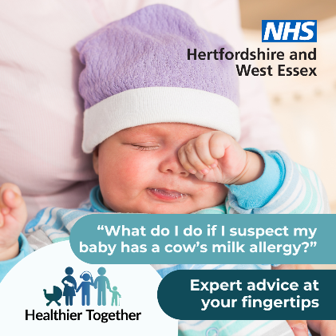 | It is really worrying when you are struggling to get your child to eat or when they seem to be reacting badly to what you have fed them. Find out what you can do to help your little one at:  https://www.hwehealthiertogether.nhs.uk/pregnant-women/worried-your-baby-unwell-under-3-months-2/child-milk-protein-allergy | Baby wearing a purple hat and blue baby grow rubbing their eye, sleepy.  Text says ‘What do I do if I suspect my baby has a cow’s milk allergy? Expert advice at your fingertips’
Infant feeding (breastfeeding)   | It is really worrying when you are struggling to get your child to eat. Help from the experts on feeding your baby is available at:  https://www.hwehealthiertogether.nhs.uk/pregnant-women/worried-your-baby-unwell-under-3-months-2/infant-feeding-first-6-months | Mother breastfeeding her baby.  Text says ‘How often should I feed my baby? Expert advice at your fingertips’
Infant feeding (bottle feeding)  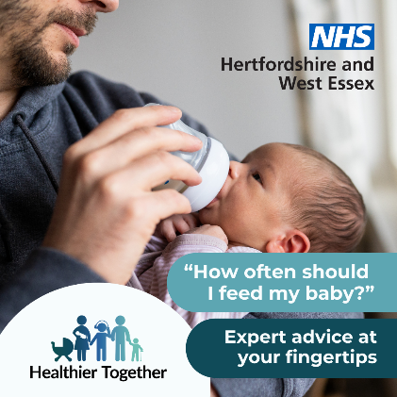 | Help from the experts on feeding your baby is available at:  https://www.hwehealthiertogether.nhs.uk/pregnant-women/worried-your-baby-unwell-under-3-months-2/infant-feeding-first-6-months | Dad holding baby feeding them with a bottle.  Text says ‘How often should I feed my baby? Expert advice at your fingertips’
New baby – what to expect   | New parent? Clinical information at your fingertips is on the Healthier Together website:  https://www.hwehealthiertogether.nhs.uk/pregnant-women/worried-your-baby-unwell-under-3-months-2/worried-about-your-baby-whats-normal-and-whats-not | Baby lying asleep with a hand stroking their head.  Text says ‘Are you a new parent and have lots of questions about your baby? Expert advice at your fingertips’
Allergies rash  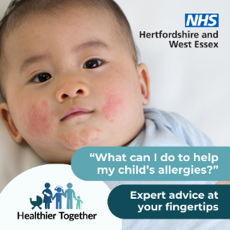 | Are you worried about your child’s allergies and what you can do to help? The Healthier Together website has a host of expert advice: https://www.hwehealthiertogether.nhs.uk/parentscarers/worried-your-child-unwell/allergies  Or…  Does your child have an itchy rash you think could be an allergy? The Healthy Together website has a host of expert information and advice: https://www.hwehealthiertogether.nhs.uk/parentscarers/worried-your-child-unwell/allergies | A baby with a rash across their cheeks and chin.  Text says ‘What can I do to help my child’s allergies? Expert advice at your fingertips’
Allergies  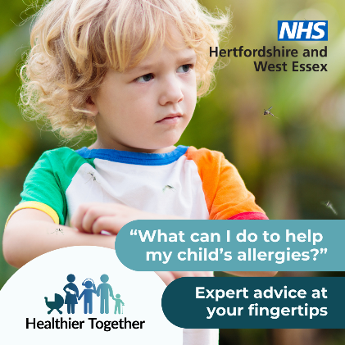 | As we start the summer season, some children may experience stings, bites or may develop hives from playing in grassy areas. Visit our healthier together website for information on where families can get help: https://www.hwehealthiertogether.nhs.uk/parentscarers/worried-your-child-unwell/allergies | Young boy scratching his arm.  Text says ‘What can I do to help my child’s allergies? Expert advice at your fingertips’
Hay fever 1  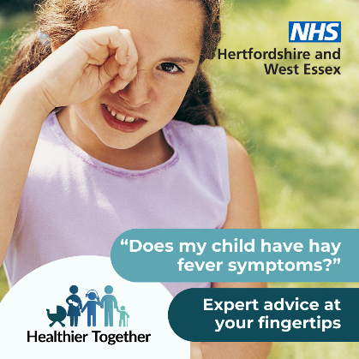 | Need advice to help your child manage their allergies? The Healthier Together website has guidance and tools to support you. Visit for details and other advice to help your family stay well: https://www.hwehealthiertogether.nhs.uk/demo/hay-fever | A young girl standing on grass rubbing her eye.  Text says ‘Does my child have hay fever symptoms? Expert advice at your fingertips’
Hay fever 2  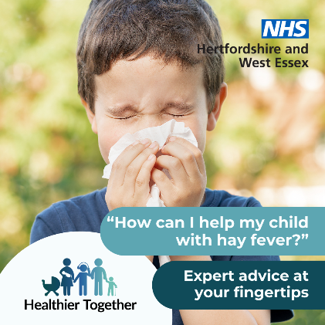 | Is your child suffering from hay fever? The Healthier Together website has a host of expert advice on how you can help with the symptoms: https://www.hwehealthiertogether.nhs.uk/demo/hay-fever | A boy blowing his nose with grass and plants behind him.  Text says ‘How can I help my child with hay fever? Expert advice at your fingertips’
Pharmacy First  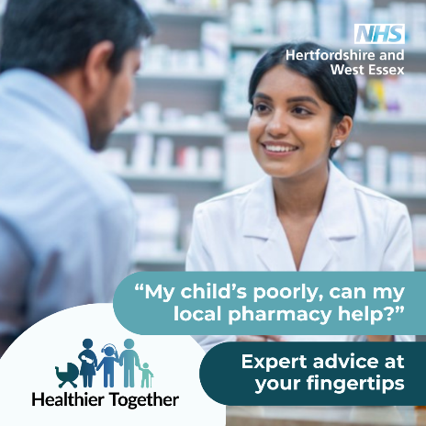 | Your local pharmacist is an expert in medicines and can treat some common conditions such as earache or insect bites, find out more at: https://www.hwehealthiertogether.nhs.uk/parentscarers/worried-your-child-unwell/pharmacy-first | Pharmacist speaking to someone over the counter at a pharmacy. Shelves of medicines behind them.  Text says ‘My child’s poorly, can my local pharmacy help? Expert advice at your fingertips’
Summer safety 1  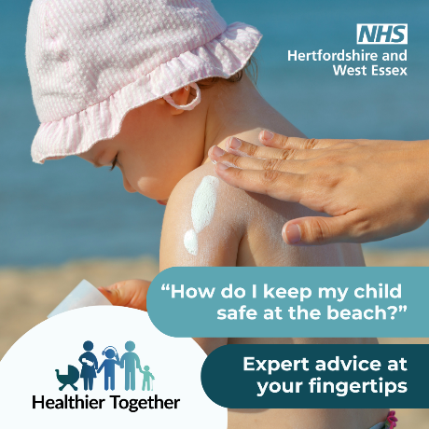 | Our summer safety page has timely reminders on how families can stay safe at the beach, including advice on protecting  children from the sun and knowing where it is safe to swim: https://www.hwehealthiertogether.nhs.uk/parentscarers/keeping-your-child-safe-and-healthy/summer-safety-tips-and-advice-1 | Baby at the beach wearing a sun hat, hand in picture putting sunscreen on them.  Text says ‘How do I keep my child safe at the beach? Expert advice at your fingertips’
Summer safety 2  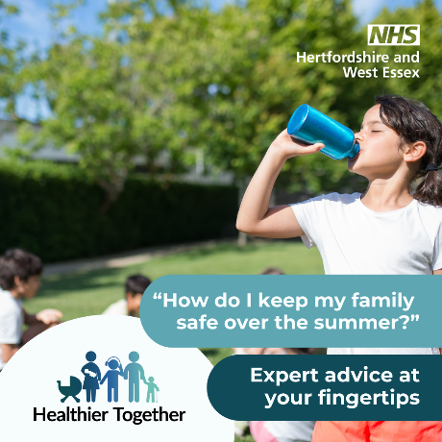 | Our summer safety page has timely reminders on how families can stay safe in the warmer weather: https://www.hwehealthiertogether.nhs.uk/parentscarers/keeping-your-child-safe-and-healthy/summer-safety-tips-and-advice-1 | Boy in a park drinking water from a bottle.  Text says ‘How do I keep my family safe over the summer? Expert advice at your fingertips’
Summer safety 3  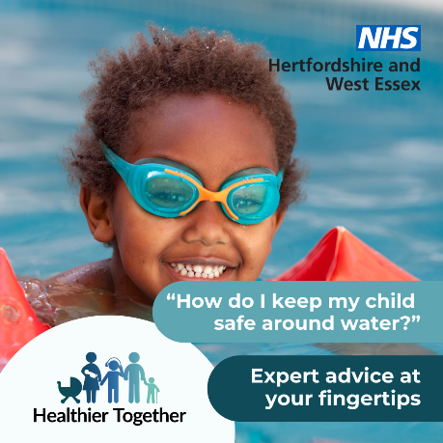 | While the arrival of warm temperatures and sunny skies in summer is usually welcome, it’s good to know how to keep your child safe when out and about enjoying the sunshine or in the water: https://www.hwehealthiertogether.nhs.uk/parentscarers/keeping-your-child-safe-and-healthy/summer-safety-tips-and-advice-1 | Young child in swimming pool wearing arm bands and goggles.  Text says ‘How do I keep my child safe around water? Expert advice at your fingertips’
Oral health  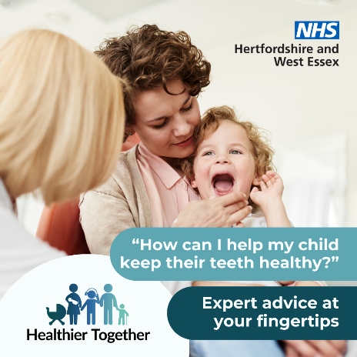 | Are you worried about how to take good care of your child’s teeth? Visit the Healthier Together website for top tips on brushing and how you can keep their teeth decay-free: https://www.hwehealthiertogether.nhs.uk/parentscarers/keeping-your-child-safe-and-healthy/oral-health | Parent holding their child on their lap with a medical professional looking into the child’s open mouth.  Text says ‘How can I help my child keep their teeth healthy? Expert advice at your fingertips’
Healthy weight  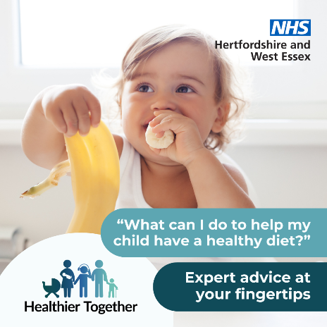 | Having the whole family eating a healthy diet is important for your child’s growth. Find out some of the ways in which you can encourage healthy habits within your family at: https://www.hwehealthiertogether.nhs.uk/parentscarers/keeping-your-child-safe-and-healthy/obesity | Baby eating a banana and holding up the banana skin.  Text says ‘What can I do to help my child have a healthy diet? Expert advice at your fingertips’
Exam stress  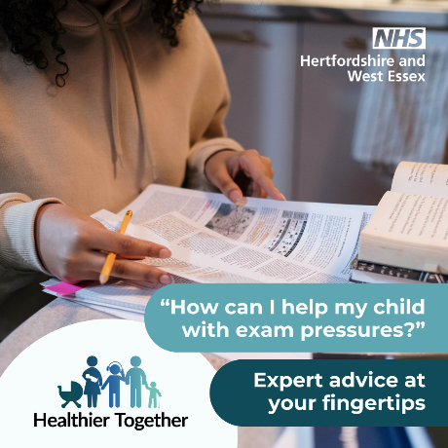 | Is your child getting ready to take exams? The Healthier Together website has expert advice on supporting your child during this time: https://www.hwehealthiertogether.nhs.uk/health-for-young-people/growing/exam-pressure | Child sitting at a table with lots of notebooks in front of them.  Text says ‘How can I help my child with exam pressures? Expert advice at your fingertips’
Teen sleep  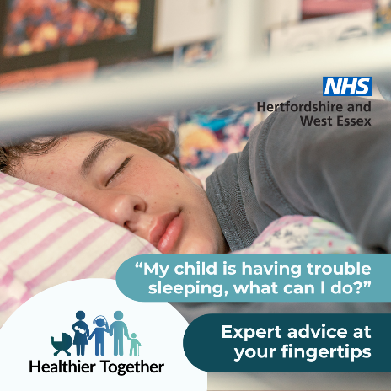 | Lots of young people find getting to sleep, staying asleep or waking up a real problem. Bad sleep can really impact on people’s mood and ability to cope with daily life. Find top tips for healthy sleep at: https://www.hwehealthiertogether.nhs.uk/health-for-young-people/staying-healthy/sleep | Child in bed asleep.  Text says ‘My child is having trouble sleeping, what can I do? Expert advice at your fingertips’
Friendships  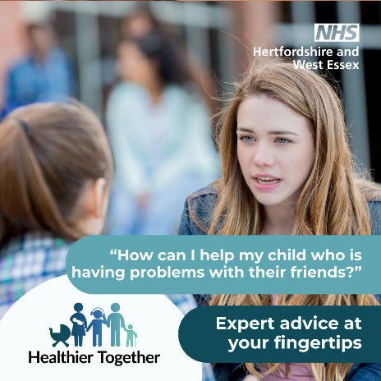 | Friendships are great when things are going well, but life can feel pretty miserable and stressful when things aren’t going so well. Share this page with your child if you think they are struggling with their friendships: https://www.hwehealthiertogether.nhs.uk/health-for-young-people/growing/friendships | Two teenagers at school or college having a chat.  Text says ‘How can I help my child who is having problems with their friends? Expert advice at your fingertips’
Healthy pregnancy  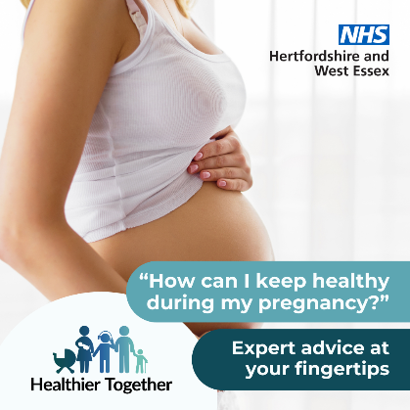 | If you’re looking for ways to stay healthy during your pregnancy, the Healthier Together website provides advice and guidance from local midwives and health visitors on topics from eating healthy to exercise: https://www.hwehealthiertogether.nhs.uk/pregnant-women/staying-healthy-pregnancy | A pregnant woman standing sideways on with her vest slightly pulled up to show her bump.  Text says ‘How can I keep healthy during my pregnancy? Expert advice at your fingertips’
Visit website 1  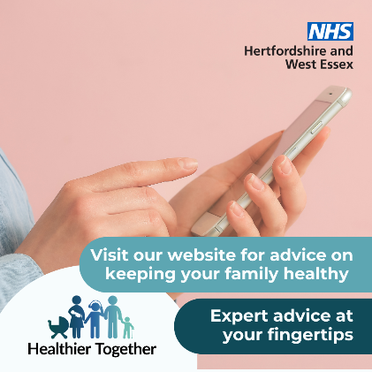 | If you have concerns about the health and wellbeing of your child(ren), the Healthier Together website offers useful information and trusted advice direct from local health professionals all in one place:  https://www.hwehealthiertogether.nhs.uk | A person holding a mobile phone.  Text says ‘Visit our website for advice on keeping your family healthy this winter. Expert advice at your fingertips’
Visit website 2  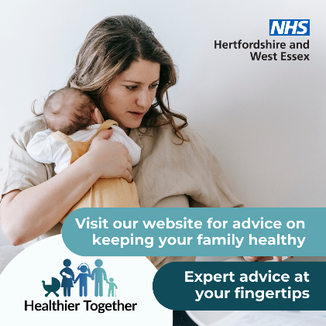 | If you’re a parent and want to know what symptoms to look out for across a range of childhood illnesses, what to do in the first instance and when to seek professional help, visit the Healthier Together website:  https://www.hwehealthiertogether.nhs.uk | A woman holding a baby against her chest.  Text says ‘Visit our website for advice on keeping your family healthy this winter. Expert advice at your fingertips’

Digital screens

Upload onto public digital screens, such as waiting rooms. Download these digital screens in full resolution (please do not save these images directly from this document).

GP screen spring/summer 1 | 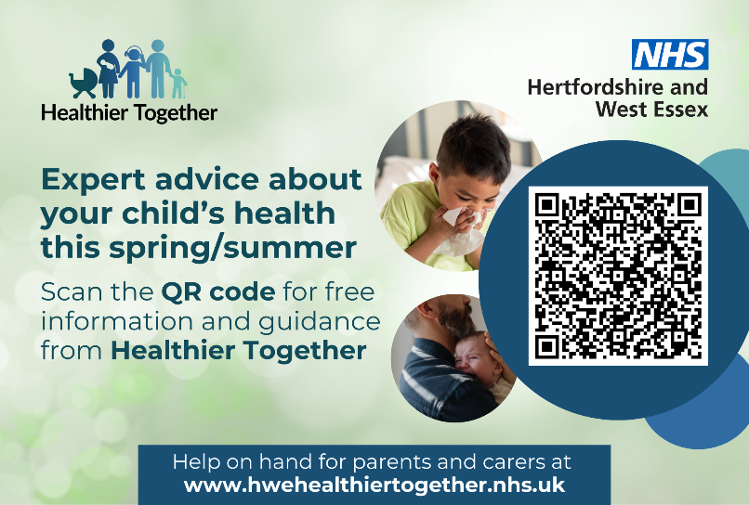
GP screen spring/summer 2 | 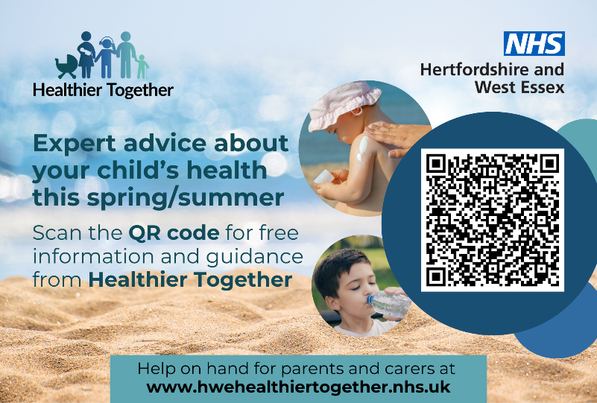
GP screen spring/summer 3 | 