Social media

The following images will be shared on the Hertfordshire and West Essex ICB social media accounts. Download the images in full resolution (please do not save the images directly from this document) and share on your own channels.

The social media posts are aimed at parents of children and young people and therefore will be shared at times of the day when parents are most likely to be on social media. These are predicted to be:

- Before the school run – 6am to 7.30am
- Immediately before school pick up time – 2.30pm to 3.15pm
- In the evening – 8pm to 10pm

Social image and name | Accompanying copy | Alt text
Allergy rash  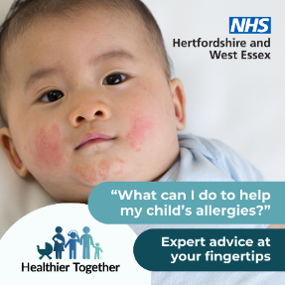 | Are you worried about your child’s allergies and what you can do to help? The Healthier Together website has a host of expert advice: https://www.hwehealthiertogether.nhs.uk/parentscarers/worried-your-child-unwell/allergies | A baby with a rash across their cheeks and chin.  Text says ‘What can I do to help my child’s allergies? Expert advice at your fingertips’
Bronchiolitis  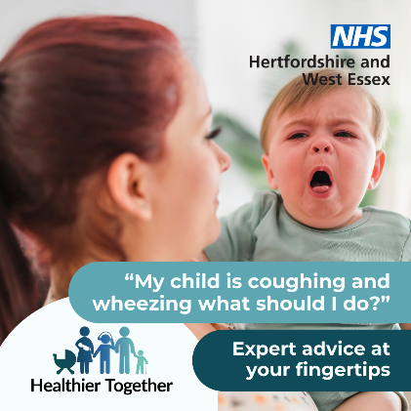 | Do you have concerns about your child’s breathing? Check signs and symptoms on the Healthier Together website to find out when to seek help: https://www.hwehealthiertogether.nhs.uk/parentscarers/worried-your-child-unwell/bronchiolitis | A parent holding their young child who has its mouth open and tongue slightly out.  Text says ‘My child is coughing and wheezing what should I do? Expert advice at your fingertips’
Childhood vaccination  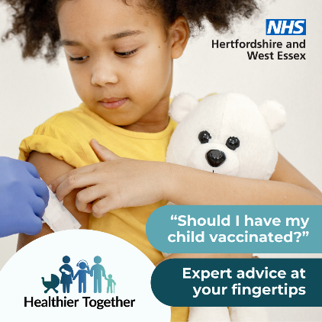 | Has your child been vaccinated to protect them from serious illness? The Healthier Together website has information about vaccinations you might need to help your family stay well: https://www.hwehealthiertogether.nhs.uk/parentscarers/keeping-your-child-safe-and-healthy/childhood-vaccinations-essential-information | A child cuddling a teddy bear looks down at her arm where she is being vaccinated.  Text says ‘Should I have my child vaccinated? Expert advice at your fingertips’
Fever  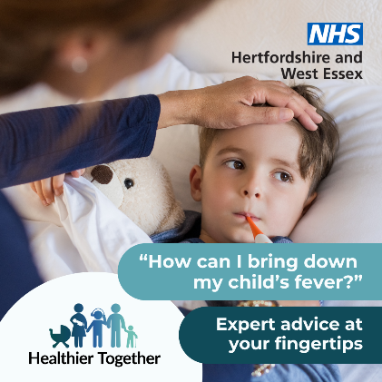 | Are you worried about your child’s high temperature? Find out what you should do next on the Healthier Together website: https://www.hwehealthiertogether.nhs.uk/parentscarers/worried-your-child-unwell/fever-high-temperature | A child lying in bed cuddling a teddy bear, while their parent checks his temperature.  Text says ‘How can I bring down my child’s fever? Expert advice at your fingertips’
Healthy pregnancy  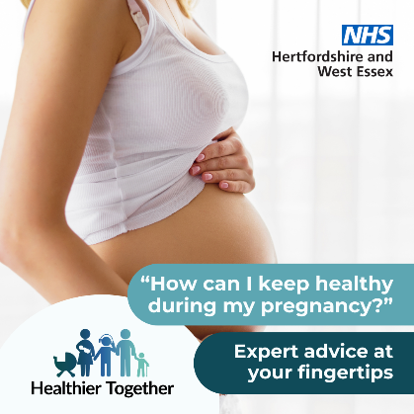 | If you’re looking for ways to stay healthy during your pregnancy, the Healthier Together website provides advice and guidance from local midwives and health visitors on topics from eating healthy to exercise: https://www.hwehealthiertogether.nhs.uk/pregnant-women/staying-healthy-pregnancy | A pregnant woman standing sideways on with her vest slightly pulled up to show her bump.  Text says ‘How can I keep healthy during my pregnancy? Expert advice at your fingertips’
Jaundice  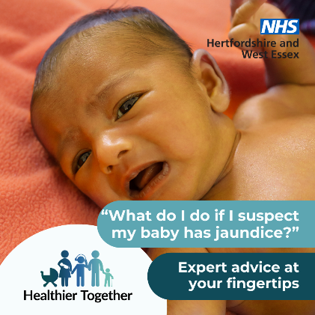 | If you suspect your baby has jaundice and are not sure what to do next, visit the Healthier Together website for advice on when and where to seek help: https://www.hwehealthiertogether.nhs.uk/parentscarers/worried-your-baby-unwell-under-3-months/jaundice | A baby lying on its back on a blanket.  Text says ‘What do I do if I suspect my baby has jaundice? Expert advice at your fingertips’
Pregnancy vaccinations  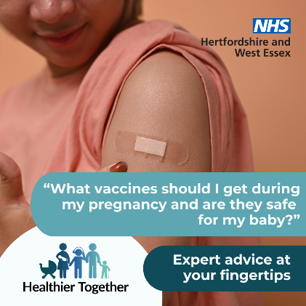 | Find out which vaccinations are recommended during pregnancy, to protect you and your baby from serious illnesses, by visiting the Healthier Together website: https://www.hwehealthiertogether.nhs.uk/pregnant-women/staying-healthy-pregnancy/vaccinations-pregnant-women | A person looking down at a plaster on their arm why they have been vaccinated.  Text says ‘What vaccines should I get during my pregnancy and are they safe for my baby? Expert advice at your fingertips’
School or nursery  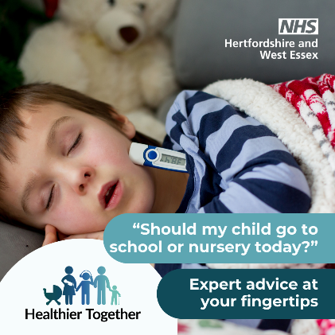 | Is your child feeling poorly? If you’re not sure if you should send them to school or nursery, check out the Healthier Together website for advice on lots of conditions: https://www.hwehealthiertogether.nhs.uk/parentscarers/child-unwell-ok-go-nurseryschool | A sleeping child in bed with a thermometer poking out of his pyjamas.  Text says ‘Should my child go to school or nursery today? Expert advice at your fingertips’
Sepsis  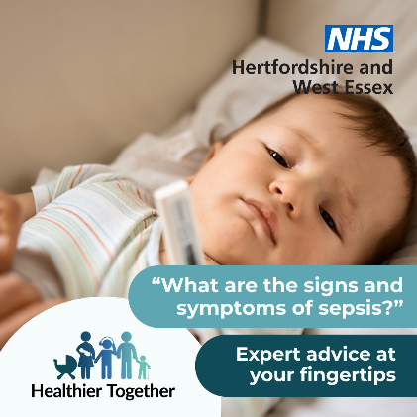 | Does your child have an infection and is feeling very unwell? Are you concerned it could be sepsis? Find out what to do next on the Healthier Together website: https://www.hwehealthiertogether.nhs.uk/parentscarers/worried-your-child-unwell/sepsis-spotting-signs | A baby lying down with a thermometer.  Text says ‘What are the signs and symptoms of sepsis? Expert advice at your fingertips’
Small batteries  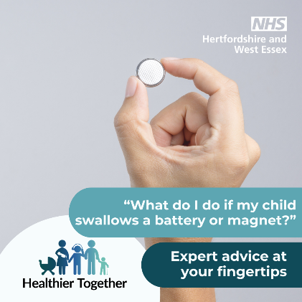 | Get advice on how to keep your child safe at home, including what to do if an accident or injury happens, by visiting the Healthier Together website: https://www.hwehealthiertogether.nhs.uk/parentscarers/worried-your-child-unwell/accidents-and-injuries-keeping-your-child-safe-home | A hand holding a small round battery.  Text says ‘What do I do if my child swallows a battery or magnet? Expert advice at your fingertips’
Visit website 1  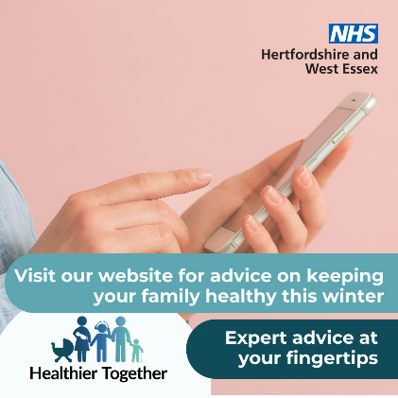 | If you have concerns about the health and wellbeing of your child(ren), the Healthier Together website offers useful information and trusted advice direct from local health professionals all in one place:  https://www.hwehealthiertogether.nhs.uk | A person holding a mobile phone.  Text says ‘Visit our website for advice on keeping your family healthy this winter. Expert advice at your fingertips’
Visit website 2  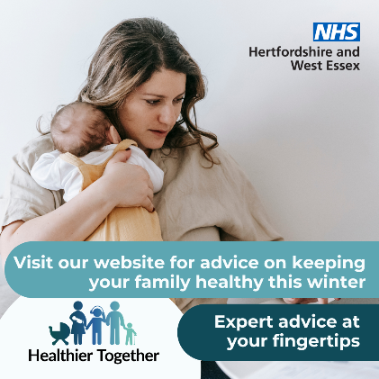 | If you’re a parent and want to know what symptoms to look out for across a range of childhood illnesses, what to do in the first instance and when to seek professional help, visit the Healthier Together website:  https://www.hwehealthiertogether.nhs.uk | A woman holding a baby against her chest.  Text says ‘Visit our website for advice on keeping your family healthy this winter. Expert advice at your fingertips’

